# USER-PATIENT ASSOCIATION

All Patient Portal users must be associated with a patient within the HIE. To begin, search for the patient using the listed criteria. Any required search terms will have an asterisk next to them**.**

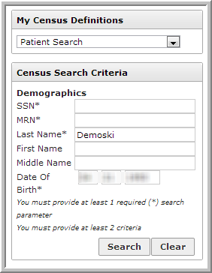

After performing the search as above, click anywhere on the row with the patient’s name.

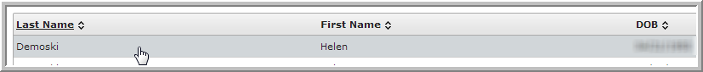

Next, choose the user’s relationship to the patient, enter a unique User Name, and the user’s email. Click **Create and Associate User**.

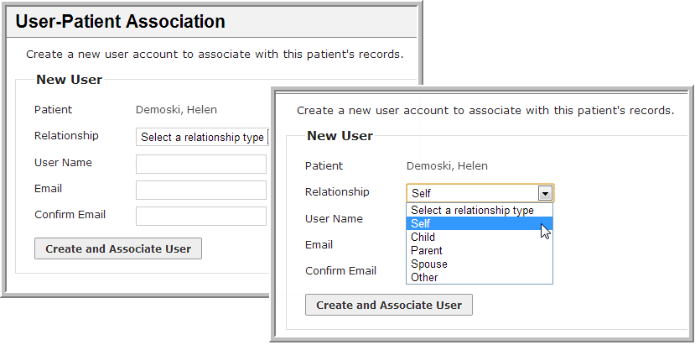

An activation email will be sent to the user, prompting them to log into their new account from a URL.

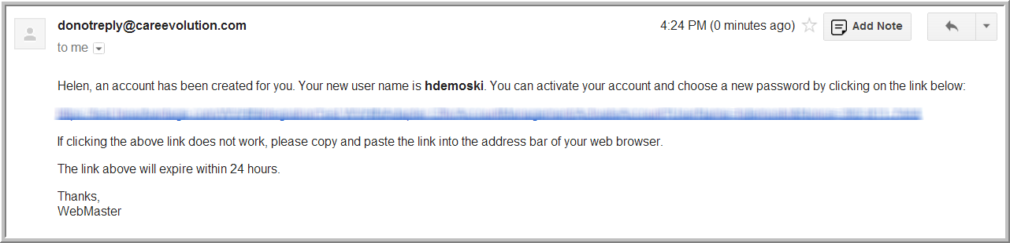

If the patient has an existing user account, click **Use an Existing User** in the upper right-hand corner of the screen.

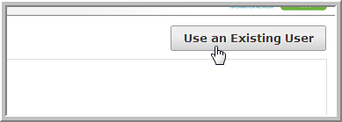

Enter the User Name and click **Associate User**.

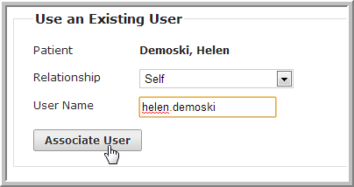

Following either method above, the following confirmation will appear. In case the User Association ever needs to be removed, click **Remove**.

